Seasonal Hydro Meteorological outlook for Indus River Basin

(Jul-Sep, 2014)

Issued on Jul 20, 2014
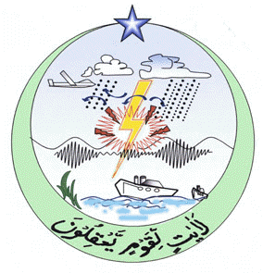

Issued by:

Dr. Khalid M Malik
(Director)

NATIONAL AGROMET CENTER (NAMC)
PAKISTAN METEOROLOGICAL DEPARTMENT
SECTOR H-8/2, ISLAMABAD
Phone: +92-51-9250592 Email: dirnamc@yahoo.com
http://namc.pmd.gov.pk/

- Introduction
- Introduction
A variety of methods including dynamical models, statistical methods, regional expert judgments and combination of them are being used to generate long-range weather forecast by the different climate prediction centers around the world. National Agromet Center (NAMC), Pakistan Meteorological Department adopts an ensemble approach to formulate seasonal weather outlook for south Asian countries included in South Asian Association for Regional Cooperation (SAARC) (on experimental basis), taking into consideration available products from major climate prediction centres by using Global Climate Models (GCMs).
This Climate Outlook developed for entire Indus Basin irrespective of national boundaries of neighboring countries. Thus, this product may differ from the official forecasts issued in those countries. Indus Basin seasonal (precipitation) outlook is predicted from ECHAM4 global climate models by using persisted sea surface temperature on 0000 Jul 01, 2014. Model is then tuned up by subtracting additional moisture from output. During validation of model, it was observed from past predictions by the model that it predicts above forecast than observed in the region. Therefore, to make the model forecast close to observation, Regional Correction Factor (RCF) for each month has been calculated to compute subtraction of additional moisture.
Accuracy of Outlook seasonal weather mainly depend upon SST used in global climate models. Even with use of accurate SST, still is uncertainty in the climate forecast due to chaotic internal variability of the atmosphere. For further information concerning this and other guidance products, users are strongly advised to contact their National Meteorological Services.
As the region receive most of the water during monsoon season as well as rise of day temperature during summer season (April- Sept) will cause increase in discharge water in the rivers. As a result, the period of predicted weather outlook for Indus Basin is from April-Sept.
This outlook will be updated regularly on before 15th of every month for next three months during summer season (April-September).
Acknowledgement: NAMC is gratefully acknowledges, the International Research Institute (IRI) for climate and Society for providing access of dynamical prediction of Global Climate Model ECHAM4P5, developed and operated by European Center for Medium-Range Weather Forecasts model’s simulations and hindcast data to support the formulation of seasonal weather outlook of Pakistan. Special acknowledge to Dr. M. Benno Blumenthal by providing guidance and assistance for using IRI climate software. All the output graphics have been prepared by using IRI climate software.
Classification of average, below average and above average
- Below Average (Blw. Ave) < -15 %,
- Average precipitation range (Ave) = -15 to +15 %,
- Above Average (Abv.Ave) > +15 %
Note: Average precipitation is computed by using Global Precipitation Climatology Centre (GPCC) gridded data by resolution (0.5x0.5º) latitude by longitude
- Map and brief of Indus river Basin and its sub region tributaries
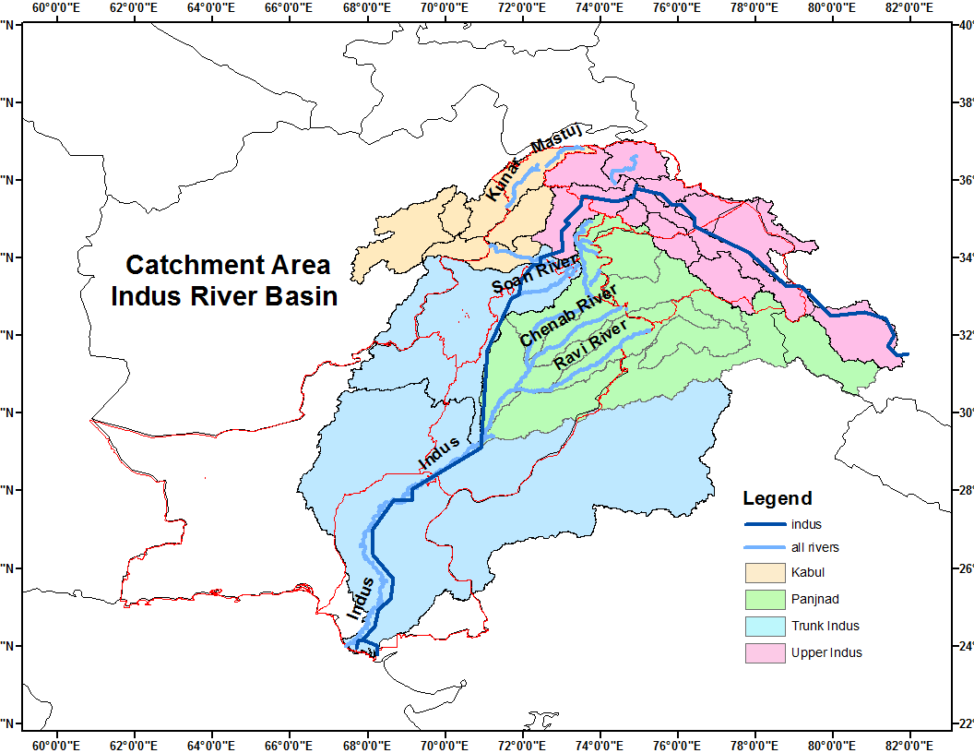
Indus River basin is main basin in Asia. It originates from China at an elevation of 5500 m. The catchment area contains seven of the world’s highest peaks after Mount Everest. The total inflow from China in the Indus river basin is estimated at 181.62 km³. Total inflow from Afghanistan to Pakistan in the Indus basin is estimated at 21.5 km³, 15.5 km³ from the Kabul river (of which 10 km³ come from Kunar river, which first enters Afghanistan from Pakistan and then flows back to Pakistan after joining the Kabul river) and 6 km³ from other tributaries (Pansjir, Gomal, Margo, Shamal, Kuram). The mean annual inflow into Pakistan from India through the western tributaries comprising the Jhelum and the Chenab (considering the Indus Water Treaty) amounts to 170.27 km³. The mean annual natural inflow into Pakistan through the eastern rivers (the Ravi, the Beas and the Sutlej) is estimated at 11.1 km³. The flow in the Indus river depends on the season, it decreases during the winter and floods the banks during the monsoons.
The Indus river has two main tributaries, the Kabul (Upper Indus and Kabul) on the right bank and the Panjnad on the left. The Panjnad is the flow resulting from five main rivers: the Jhelum and Chenab, known as the western rivers with the Indus river, and the Ravi, Beas and Sutlej, known as the eastern rivers.
This hydro-meteorological climate outlook is developed keeping in view the needs of water managers, authorities engaged in DRM, agriculture and power sector who are directly concerned to changes in precipitation patterns in Indus Basin. Experts from related fields are encouraged for feedback so that the climate outlook may further fine-tuned as per societal needs.
- Synoptic situation
- Location of jet stream (U wind at 200 hPa) is at normal position with slightly higher than normal intensity over north. Most of the region including Pakistan, western Nepal and northern parts of India may prevail slightly above normal zonal winds at 200 hPa.
- A trough at 500 hPa is expected to be over west of the country. However a strong ridge may prevail over the country during the season which causes to reduce influence of monsoon over the country.
- Surface temperatures are expected to be on higher side than normal all over the country with higher values over central parts.. However, northern and southern parts may prevail normal surface temperature.
- North Atlantic Oscillation (NAO) is in negative phase (-0.97) during Jun. As a result normal track of western disturbances will persist. http://www.cpc.ncep.noaa.gov/products/precip/CWlink/pna/norm.nao.monthly.b5001.current.ascii.table
- The SST anomaly in the Nino3.4 region in recent weeks has been near the borderline of neutral and El Nino during the mid-May to mid-June period, 2014. For May the Nino3.4 SST anomaly was 0.45 C, indicative of neutral conditions but very close to the borderline of El Nino, and for Mar-May it was 0.16 C. It is predicted that for likelihood for a transition from neutral ENSO conditions to El Niño conditions during summer 2014, with probabilities of El Niño rising to 70% by Jun-Aug 2014, and to approximately 80% by northern autumn 2014. The latest set of model ENSO predictions, from mid-June. For all model types, the probability for neutral ENSO conditions is below 25% between Aug-Oct 2014 and Jan-Mar 2015, being between 30% and 39% during Jun-Aug and Jul-Sep, and again at the end of the forecast period in Feb-Apr 2015. Probabilities for El Niño rise to more than 75% during the very same times, Aug-Oct 2014 to Jan-Mar 2015. Probabilities for El Niño fall to about 60% by Feb-Apr 2015. No model predicts La Niña conditions for any of the 3-month periods between Jun-Aug 2014 and Feb-Apr 2015. .(http://iri.columbia.edu/our-expertise/climate/forecasts/enso/current/?enso_tab=enso-cpc_update)
Probability outlook: La Nina (1%), Neutral (26%) and El Nino (73 %) during May-Jun-Jul, 2014 season
- Arabian Sea Surface Temperatures are expected to be slightly above normal near western coastal belt of Pakistan.
- Caspian Sea surface temperatures expected to be slightly above normal over southern half and below normal over upper half.
- Mediterranean Sea surface temperatures are normal to slightly above normal.
- Bay of Bengal Sea Surface Temperatures are close to normal.

- Seasonal weather outlook (Jul-Sep, 2014)
- Summary
Normal to below normal surface runoff water is expected during the season (JAS)
Synthesis of the latest model forecasts for Jul-to-Sep 2014 (JAS), current synoptic situation and regional weather expert’s judgment indicates that normal to slightly below normal surface runoff water is expected during the predicted season with below over upper Indus and Punjnad (Jhelum, Chenab, Ravi and Sutlej), significantly below over trunk and average over Indus and Kabul rivers. Day temperatures are likely to be above normal during whole predicted months over catchment areas of the basin.
- Seasonal surface runoff water outlook:
Surface runoff water in the Indus river basin including Upper Indus, Kabul, Panjnad and Trunk Indus has been predicted on the basis of expected rainfall in the catchment areas of Indus basin and day temperature in the region during predicted season. The main points of water availability outlook are as under:-
- Synoptic situation and model seasonal outlook shows that enough surface runoff water is likely over catchment areas of main reservoir (Terbala dam). No short fall of surface runoff water is likely during the season in Terbela dam.
- Short fall of surface runoff water in the catchment areas of Mangla dam is expected during the season.
- Surface runoff water in the Ravi river will be slightly on higher side during the month of September
- Average surface runoff water is expected in Upper Indus, Kabul and Indus river Basin as a whole.
- Below average surface runoff water is expected in Panjnad basin with significantly low over the eastern rivers (the Ravi and the Sutlej) and average over the western rivers (the Jhelum and the Chenab)
- Surface runoff water in Indus Basin will gradually increase during predicted season
- Urban / flash flooding over southern parts of the country can’t be ruled out.

Note: Departure of Area-weighted rainfall of Indus Basin and its sub-region has been computed by subtracting ECHAM predicted monthly/seasonally rainfall from GPCC of corresponding month/season.
- Monthly outlook

  - Jul, 2014

Comparison of expected (red bar), average (blue bar) and departure (green line) of rainfall from normal over catchment area of Indus and its sub-regions.
Indus Basin: Signigicantly below average rainfall is expected over catchment area of Indus baisn and above normal day temperature over the region. That would result above normal surface runoff water in the rivers.
- Upper Indus: Slightly below normal rainfall is expected over catchment of Upper Indus. In addition melting snow/ ice may increase surface runoff water in the upper Indus tributeries.
- Kabul: Average surface runoff water is expected in the Kabul river because of ice melting and continous rainfall over the region.
- Panjnad: Slightly below average rainfall is expected during July but due to high day temperature over northern region will causes normal surface runoff over western rivers of Panjnad (Jhelum and Chinab). However less surface runoff water is expected in the eatern rivers of Panjnad (the Ravi and the Sutlej
- Trunk Indus: Below average rainfall over southern parts of the countury as well in the catchment areas of trunk cause slightly below average surface runoff water in the trunk especially at Kotri barrage during July.

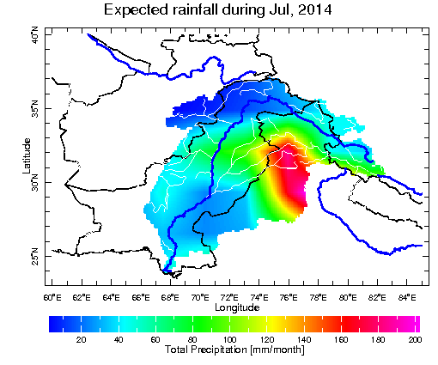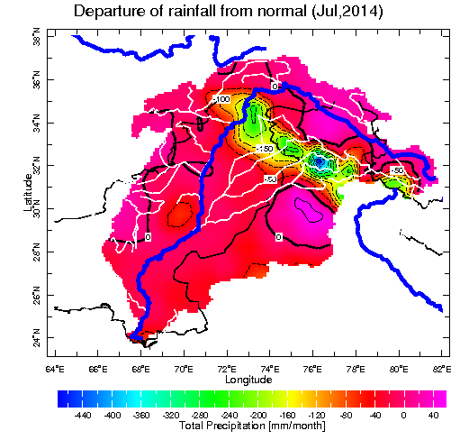
a) b)
Spatial distribution of a) expected rainfall and b) departure from normal rainfall during June, 2014

  - August, 2014

Comparison of expected (red bar), average (blue bar) and departure (green line) of rainfall from normal over catchment area of Indus and its sub-regions.
Indus Basin: Below Normal rainfall is expected over Indus baisn indicates below normal runoff water in the rivers. However above average day temperature are exepcted over northern region causes increase intensity of surface runoff in the Indus Basin. No shortfall of water would be observed in the water reserviors during July. Better water management would lead to fill Tarbela reservior as per schedule.
- Upper Indus: Average rainfall is expected over catchment of Upper Indus. Water flow in the Indus will be expected as normal. Above normal day temperature will increase surface runoff level over northern areas rivers such as Konar and Swat rivers.
- Kabul: Above normal rainfall in the catchment areas is likely as well as above day temperature would generate slightly above normal flow in the kabul river.
- Panjnad: Below normal rainfall in the catchment would cause below normal surface runoff in western rivers. Below normal surface runoff water is expected over eastern rivers (the Ravi and the Sutlej) as well as western rivers (the Chinab and the Jhelum). Water shortage is expected around bank of the basin. This would give negative impact on the agricultural land in the region.
- Trunk Indus: Significantly below normal rainfall over southern parts of the countury and in the foothills of Suliman rainges will causes decrease water flow in the trunk Indus. Below normal water flow is expected in the trunk especially at Kotri barrage during July.
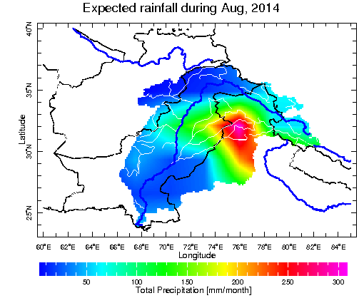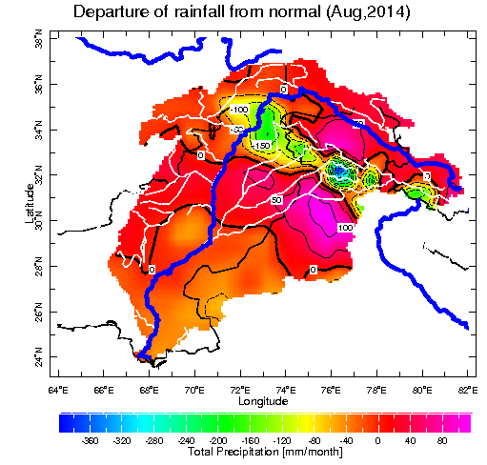
a) b)
Spatial distribution of a) expected rainfall and b) departure from normal rainfall during July, 2014
  - September, 2014

Comparison of expected (red bar), average (blue bar) and departure (green line) of rainfall from normal over catchment area of Indus and its sub-regions
Indus Basin: Normal rainfall is expected over catchment area of Indus baisn that would lead to above normal surface runoff water in the rivers.
- Upper Indus: Normal rainfall is expected over catchment of Upper Indus. As a result, normal runoff would occur over northern areas rivers.
- Kabul: Above normal rainfall in the catchment will give slightly above normal flow water is kabul river.
- Panjnad: Normal rainfall in the catchment areas would lead to normal surface runoff in western as well as in easetern rivers. Surface water flow level will rise in lower bank of the rivers.
- Trunk Indus: Slightly below normal rainfall over southern parts of the countury as well in the catchment areas of trunk cause decreased surface runoff water in the trunk. This surface water will give neagtive impact on rabi season crop in the Sindh province.
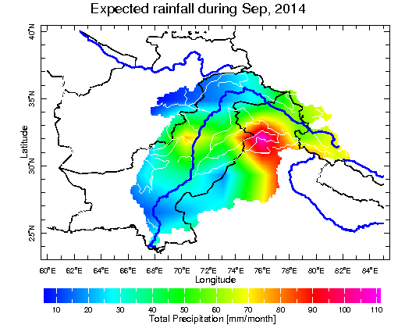
a) b)
Spatial distribution of a) expected rainfall and b) departure from normal rainfall during August, 2014

  - Seasonally (Jul-Sep,2014)

Comparison of expected (red bar), average (blue bar) and departure (green line) of rainfall from normal over catchment area of Indus and its sub-regions.
Indus Basin: As a whole, slightly below normal rainfall is expected over catchment area of Indus baisn and may yield normal surface runoff water in the rivers. However day temperature is expected above normal over northern region would help increase snow melt component in the river. As such, no shortfall of surface runoff likely in the main reservior (Terbela).
- Upper Indus: Slightly below normal rainfall is expected over catchment of Upper Indus. In addition melting of snow/ ice may increase surface runoff water in the rivers.
- Kabul: Average surface runoff water is expected in the Kabul river during the predicted season. No short fall is likely from kabul river during the season.
- Panjnad: Average rainfall is expecpected during the season that would lead to normal surface runoff in the castchment of Panjnad. No significant short fall of surface runoff is likely in all the rivers (the Jhelum, the Chenab, the Ravi, and the Sutlej).
- Trunk Indus: Below normal rainfall over southern parts of the countury as well in the catchment areas of trunk cause decreased surface runoff water in the trunk region during the season. That surface runoff water would give negative impact on agriculture in the southern parts of the country.
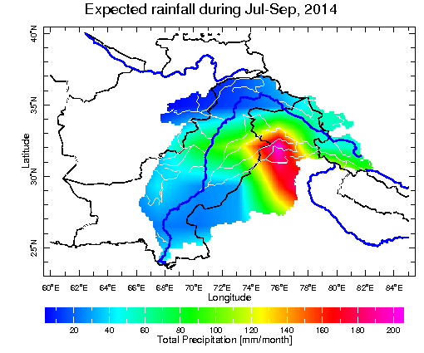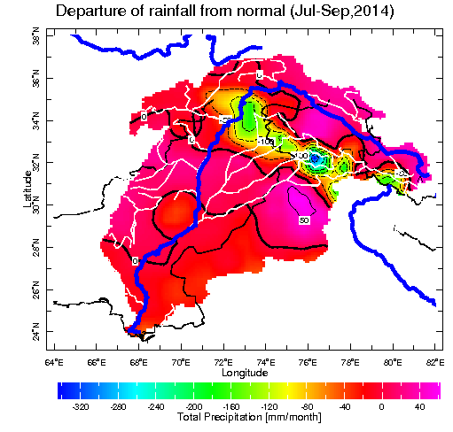
a) b)
Spatial distribution of a) expected rainfall and b) departure from normal rainfall during the season (Jun-Aug, 2014).

Note: Research wing of NAMC is regularly monitoring variation in synopitc situation of the globe and using different global climate models regional weather prediction data for prepration of this weather outlook. Seasonal weather outlook for SAARC region will be issues 10th of every month with three months in advance weather outlook. Lastest seasonal weather summay can be download from NAMC web site mentioned below: http://namc.pmd.gov.pk/

